**SAVEETHA** 

**INSTITUTE OF MEDICAL AND TECHNICAL SCIENCES, CHENNAI – 602105**

**CAPSTONE PROJECT REPORT**

**TITLE**

# **Memory Management In OS**

**Submitted to**

**SAVEETHA SCHOOL OF ENGINEERING**

**Course Code**: CSA0405

**Course Name**: Operating Systems of File System Implementation

**Submitted By:**

**K. Someshwar**

**(192210045)**

**B. Revanth Harsha Vardhan (192210076)**

**Slot:** SLOT C

**Guided by**

**Yuvarani R**

**ABSTRACT:**

Memory management is a critical aspect of modern operating systems, facilitating the efficient utilization of system resources and ensuring seamless execution of processes. This abstract presents a memory management project aimed at deepening participants' understanding of operating system principles while honing their practical skills in system programming. The project focuses on implementing key memory management concepts, including memory allocation, address translation, virtual memory, and performance optimization, within an operating system environment.

Through hands-on exploration and experimentation, participants gain valuable insights into the complexities and challenges of managing memory resources in real-world computing scenarios. By engaging in the project, they develop critical thinking, problem-solving abilities, and practical skills that are essential for success in the field of computer science. Furthermore, the project serves as a foundation for further study and exploration in operating system design and development, empowering participants to contribute to advancements in the field and drive innovation in the ever-evolving landscape of technology.

## **INTRODUCTION:**

Memory management stands as a cornerstone in the realm of operating systems, orchestrating the intricate dance between software and hardware to optimize resource utilization and ensure smooth system operation. At its core, memory management is tasked with the efficient allocation, tracking, and retrieval of memory resources within a computing environment. In the dynamic landscape of modern computing, where applications demand ever-increasing memory resources, understanding and implementing effective memory management strategies are paramount for the seamless functioning of operating systems.

The aim of this project is to delve into the fundamental principles of memory management within operating systems, unraveling the complexities inherent in managing memory resources efficiently. By embarking on these endeavours, we seek to comprehend the underlying mechanisms that govern memory allocation, address translation, and virtual memory implementation. Through practical exploration and experimentation, we aim to gain insights into the challenges posed by memory fragmentation, security concerns, and performance optimization in memory management systems.

Furthermore, by delving into the nuances of memory management, this project endeavours to equip participants with the knowledge and skills necessary to design, implement, and evaluate robust memory management solutions. Beyond the immediate scope of this endeavour, our aim is to foster a deeper understanding of operating system internals and cultivate a passion for system-level software development. Ultimately, through collaborative learning and hands-on experimentation, we aspire to unravel the mysteries of memory management and unlock new avenues for innovation in operating system design.

**OBJECTIVES:**

The primary objective of this project is to provide participants with a comprehensive understanding of memory management principles within the context of operating systems. By engaging in hands-on activities, participants will delve into key concepts such as memory allocation, address translation, virtual memory, and fragmentation management.

Another objective of the project is to hone participants' practical skills in system programming and software development. By designing and implementing memory management algorithms, participants will strengthen their programming proficiency and problem-solving abilities. They will have the opportunity to explore different memory management strategies, analyse their performance characteristics, and optimize their implementations to achieve efficient resource utilization and system performance. At its core, memory management is tasked with the efficient allocation, tracking, and retrieval of memory resources within a computing environment.

Furthermore, the project aims to foster a collaborative learning environment where participants can exchange ideas, share insights, and support each other's learning journey. Through group discussions, peer review sessions, and collaborative projects, participants will not only deepen their understanding of memory management concepts but also enhance their communication and teamwork skills. By working together towards common objectives, participants will cultivate a sense of community and camaraderie, enriching their overall learning experience.

Top of Form

**LITERATURE REVIEW:**

Memory management in operating systems is a topic that has been extensively studied and researched in the field of computer science. Numerous scholarly articles, textbooks, and research papers have contributed to our understanding of memory management principles, algorithms, and techniques. One seminal work in this area is Tanenbaum and Woodhull's "Operating Systems: Design and Implementation," which provides a comprehensive overview of memory management concepts, including paging, segmentation, and virtual memory.

Classic algorithms such as First Fit, Best Fit, and Worst Fit have been extensively studied and compared in terms of their efficiency and effectiveness. Additionally, research has explored advanced allocation strategies such as buddy allocation, slab allocation, and dynamic memory partitioning, aiming to address the challenges of fragmentation and resource contention.

Classic algorithms such as First Fit, Best Fit, and Worst Fit have been extensively studied and compared in terms of their efficiency and effectiveness. Additionally, research has explored advanced allocation strategies such as buddy allocation, slab allocation, and dynamic memory partitioning, aiming to address the challenges of fragmentation and resource contention.

Overall, the literature on memory management in operating systems provides a rich source of knowledge and insights that can inform the design and implementation of memory management systems. By reviewing and synthesizing existing research, this project aims to build upon the foundation laid by previous studies and contribute to advancements in the field of operating system design and development.

**OUTPUT:**

Best Fit:

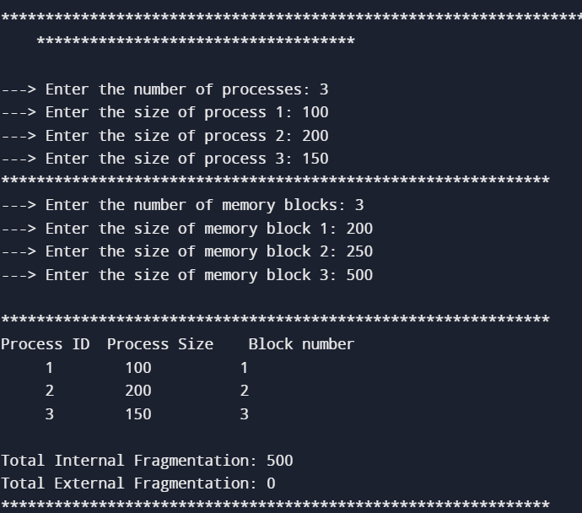

First Fit:

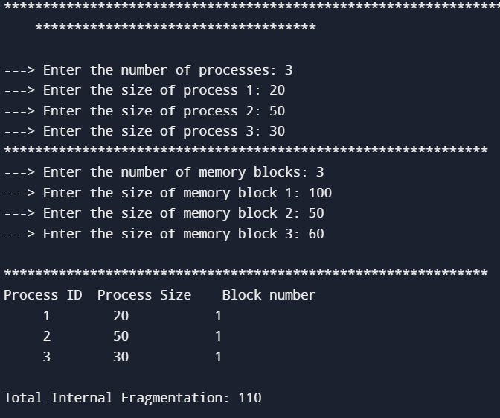

**CONCLUSION:**

In conclusion, the literature review highlights the rich body of research and scholarship surrounding memory management in operating systems. Through the review of seminal works, research papers, and textbooks, we have gained insights into key memory management concepts, algorithms, and techniques.

By synthesizing and analysing existing research, this literature review serves as a foundation for the memory management project outlined in this study. It provides valuable insights and perspectives that inform the design, implementation, and evaluation of memory management systems within an operating system environment. Furthermore, the literature review underscores the importance of memory management in ensuring efficient resource utilization, system performance, and security.

Moving forward, the findings from the literature review will guide our approach to the memory management project, informing our choice of algorithms, techniques, and evaluation metrics. By building upon the insights gleaned from existing research, we aim to contribute to advancements in the field of operating system design and development. Through collaborative effort, experimentation, and innovation, we aspire to unravel the mysteries of memory management and pave the way for future breakthroughs in operating system technology.

Top of Form

**REFERENCES:**

* Baker, M., Sullivan, M.: The Recovery Box: Using Fast Recovery to Provide High Availability in the UNIX Environment. In: Proceedings of the Summer 1992 USENIX Conference, Texas (June 1992).
* Belady, L.A., Parmelee, R.P., Scalzi, C.A.: The IBM History of Memory Management Technology. IBM Journal of Research and Development 25(5), 491–504 (1981)
* Brukman, O., Dolev, S., Kolodner, H.: Self-Stabilizing Autonomic Recoveree for Eventual Byzantine Software. In: Proceedings of IEEE International Conference on Software-Science Technology & Engineering (SwSTE 2003), Israel (2003)
* Castro, M., Liskov, B.: Proactive Recovery in a Byzantine-Fault-Tolerant System. In: Proceedings of the Fourth Symposium on Operating Systems Design and Implementation, San Diego, CA, pp. 273–288 (October 2000)
* Daley, R.C., Dennis, J.B.: Virtual memory, processes, and sharing in Multics. In: Proceedings of the first ACM symposium on Operating System Principles, Gatlinburg, TN, pp. 12.1-12.8 (January 1967)
* Dijkstra, E.W.: Self-Stabilizing Systems in Spite of Distributed Control. Communications of the ACM 17(11), 643–644 (1974)
* Dolev, S., Yagel, R.: Memory Management for Self-Stabilizing Operating Systems. Technical report, #05-05, Computer Science, Ben-Gurion University, Beer-Sheva, Israel (June 2005)
* Dolev, S., Haviv, Y.A.: Self-Stabilizing Soft Error Resilient Microprocessor. In: Müller-Schloer, C., Ungerer, T., Bauer, B. (eds.) ARCS 2004. LNCS, vol. 2981, pp. 31–46. Springer, Heidelberg (2004); Also, to appear in IEEE Transaction on computers.
* Kistler, M., Shivakumar, P., Alvisi, L., Burger, D., Keckler, S.: Modeling the effect of technology trends on the soft error rate of combinational logic. In: ICDSN. LNCS, vol. 72, pp. 216–226 (2002)